<https://my-personality-test.com/>

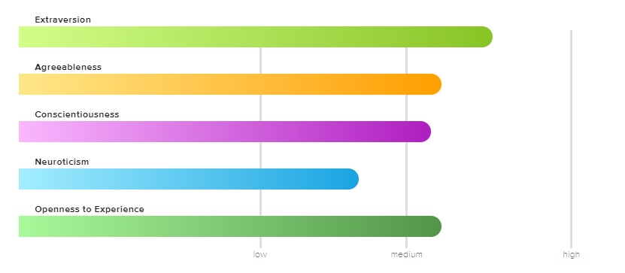

**Openness to Experience – Medium Characteristics**

You have a medium level of openness to experience. At times, you can be very creative, curious, and adventurous. At other times, you prefer routine. You are able to find a great balance between ideas and practicality.

You typically are a good problem-solver. When you are faced with a problem, you consider the tried-and true methods, but are also able to think outside the box. You are able to handle whatever life throws at you.

People who are moderate in openness to experience are well-suited for careers that balance creativity with stability – for example, journalism, photography, graphic design, or research.

**Extraversion – Medium Characteristics**

You have a medium level of extraversion. This means that at times, you get your energy from being around others; but at other times, you get your energy by being alone. Life is all about balance, and for you, it’s important to spend time alone and with others. You don’t mind being the center of attention at times, but you don’t seek out ways to be the center of attention either.

Because you have traits of both an introvert and extravert, you know when to speak up and when to stay silent. You are able to recognize the times when you need to speak up and be assertive, and can find the courage to have those difficult conversations when necessary.

Jobs for those who are moderately extraverted include those that allow building relationships with others, but also allow periods of time to work alone. The best jobs for these individuals include counseling, human resources, or being a director.

**Neuroticism – Low Characteristics**

You scored low in neuroticism. You are very emotionally stable. While others may experience emotions of extreme highs and extreme lows, you tend to stay somewhere in the middle. Others often describe you as calm, level-headed, and optimistic.

Because of your tendency to tend to “go with the flow” in life, you have a hard time understanding people who are extremely emotional or anxious. Those who score low in neuroticism have a difficult time understanding and spending time with people who are highly neurotic. You typically prefer spending time with people who are relaxed, like yourself.

In stressful situations, you are able to remain calm and think clearly. Others typically look to you for guidance when this occurs, and in many situations, you are a natural leader.

Because those who score low in neuroticism are so level-headed, they tend to do well in leadership roles. They typically make great managers and executives.

### Conscientiousness – Medium Characteristics

You scored medium on conscientiousness. At times, you are very driven and hard-working, but that doesn’t mean you don’t like to have fun! You are always able to set a comfortable balance between work and fun.

Your home isn’t spotless, but it is clean and organized. You don’t mind leaving a mess behind when you are in a hurry, but you make sure to clean it up later.

Your conscientious traits make you successful in your career – you are very reliable and hard-working. This, along with your friendly and relaxed personality, makes you a great employee to have. You finish what is expected of you, but aren’t too busy working to build relationships with your coworkers and supervisors.

### Agreeableness – Medium Characteristics

You scored medium in agreeableness. Others often describe you as friendly and helpful. You typically try to avoid conflict, but when a situation arises, you aren’t afraid to speak up. In group situations, you are able to find a comfortable balance between keeping everyone happy, but also speaking up and making the right decision.

You are a fairly generous person, and enjoy doing what you can to help others. In your free time, you may find yourself volunteering or helping friends and family with various projects. You believe helping others is important, but have not felt the need to devote your entire life to helping others. You do what you can to help, while making sure you are not being taken advantage of.

1. What do the results of these tests mean for you?

Overall, I think the results have reasonable grounds for their result as I can reflect on some of the result to be accurate. Majority of the category I have scored a medium besides from my emotional trait. It says I have a very stable emotional control and that I can always remain calm. That was a surprise to me as I would get anxious and nervous when the due date is near or when something unexpected has happened.

1. How do you think these results may influence your behavior in a team?

I think that since I’ve read this result, now I will be aware of what my personality is in a team environment and I will try to live up to it rather that just being myself. Before I knew these results, my actions and emotions were a result of what I felt was right. Now that there is a result and definition, I will feel more incline to achieve it.

1. How should you take this into account when forming a team?

I should definitely find people that have the same result as myself. This will enable the same ‘type’ of people to work together to achieve something greater. Another aspect of a team is to ensure all members are working together and can support each other to draw out the best in one n other.